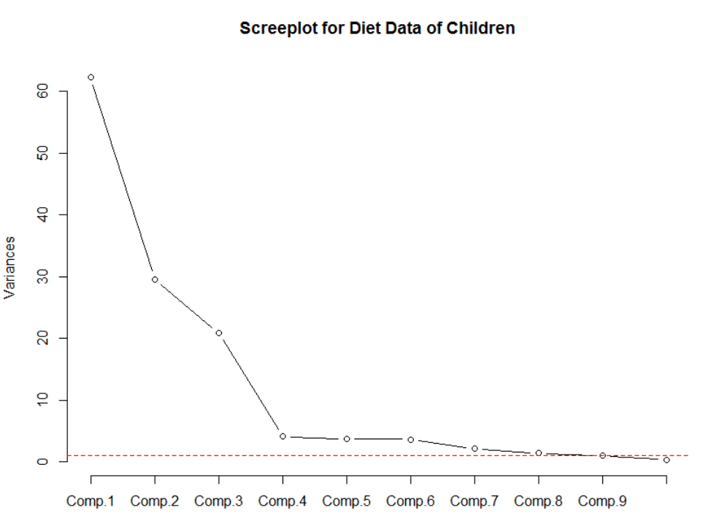

Scree Plots Showing Significant Components